**Maulana Abul Kalam Azad University of Technology**

A Project submitted in partial fulfillment of

The requirement for the Honours Degree of

Bachelor of Computer Applications

**Trippy**

Paper Code: BCAD581

Year of Examination: 2023

**Submitted by**

**STUDENTS NAME ROLL NO. REG. NO**

SouravSaha 26601221037

Supratim Das 26601221042

Somdipta Sen 26601221041

Shreyasi Dutta 26601221010

**Of**

**Bengal School of Technology & Management**

**SELF CERTIFICATE**

This is to certify that the dissertation/ project report entitled Trippy is done by us is an authentic work carried out for the partial fulfillment of the requirement for the award of the BCA under the guidance of respected class teacher, also certify that I am aware of the “BCA project & project report standard 2014, issued by your university name Maulana Abul Kalam Azad University of Technology, This project report is based on that standard. The matter embodied in this project work has not been submitted earlier for award of any degree or diploma to the best of my knowledge and belief.

_________________________________________

**STUDENTS NAME ROLL NO. REG. NO**

SouravSaha 26601221037

Supratim Das 26601221042

Somdipta Sen 26601221041

Shreyasi Dutta 26601221010

**Institution Name-**Bengal School of Technology & Management

**ACKNOWLEDGEMENT**

I would like to express my heartfelt gratitude to all those who have contributed to the successful completion of this minor project on trippy website. This endeavor would not have been possible without the support, guidance, and encouragement of several individuals and collage.

First and foremost, I extend my sincere thanks to Sudipta madam, our project mentor, for their invaluable guidance and mentorship throughout the duration of this project. Their expertise, constructive feedback, and unwavering support played a pivotal role in shaping the project into its final form.

I would also like to express my gratitude to the faculty members of the BCA department for providing us with an enriching academic environment and for giving us the opportunity to work on this project, which allowed us to apply our theoretical knowledge to practical implementation.

I am indebted to my peers and friends who provided me with constant motivation and assistance whenever it was needed. Their collaborative spirit and willingness to brainstorm ideas significantly contributed to the project's success.

Furthermore, I would like to extend my thanks to the various online resources, forums, and communities that provided valuable insights and solutions during the development process.

Last but not least, I extend my heartfelt thanks to my family for their unwavering support and encouragement. Their belief in my abilities has been a constant source of inspiration.

In conclusion, I express my deepest gratitude to all those who have contributed to this project, directly or indirectly. Your support has been invaluable, and I am truly grateful for the opportunity to work on this tour and travels website minor project.

**STUDENTS NAME ROLL NO. REG. NO**

SouravSaha 26601221037

Supratim Das 26601221042

Somdipta Sen 26601221041

Shreyasi Dutta 26601221010

**Title Of The Project:**

**Trippy**

**INDEX:-**

|  |  |  |
| --- | --- | --- |
| Sl. No | Topic | Page No |
| 1 | Introduction |  |
| 2 | Objective |  |
| 3 | Software Requirement Specification |  |
| 4 | Software Development Tools |  |
| 5 | Software Development Life Cycle |  |
| 6 | System Planning |  |
| 7 | System Design |  |
| 8 | DFD, ERD and Flowchart |  |
| 9 | Snapshots Followed by Corresponding Code |  |
| 10 | Testing Techniques |  |
| 11 | Conclusion |  |
| 12 | Future Scope of Project work |  |

**Introduction**

Online Tour and Travel is a very user friendly project. In this project user can easily understand and book all packages and also register for hotel. In this project there are various types of forms, like all types of packages, book for package and Room Registration Page in which user can insert his personal needs & facilities then upload his form by which user can register in the web site. In this website user can also pay money through credit card.

This site provides different packages, destination, and hotel booking services in one particular state of India. Himachal Pradesh is very popular hill station of north India. Visitors enjoy snow covered mountain peaks and adventure sports like trekking, mountaineering and skiing.

In this website, according to the tour packages it provides services like online booking facilities for all packages and hotels registration to the customer. In this project user can easily understand and fill up the Room Reservation form. User can search for various types of rooms.

Online Tour and Travel is a web based application made in Asp.Net. So with the help of this project user can apply for packages of tour and room reservation.

**Objective Of your project:**

The website has interactive design. Visitors can use a search function that isrealized with the help of Elasticsearch technology and quickly matches with theusers’ requests. Also, the navigation bar has categorized aswell as Log In and Sign In. The interactive design improves the browsingexperience.

This system provides Online Registration, Tour Package Information, ticket booking and all other destinations. The purpose of this project is very clear that user can find facilities easily &service providers also get good customers very easily. Customer can register in the website & can create his own registration then he can receive email for his status related to his reservation and book all packages.

The Main Goal of this project is to provide very faster booking services for different types of packages so any user can get this service very easily. Our objective is to make strong relationship with customers so that they can enjoy the holiday of their dreams.

**Admin:**

**Dashboard:** In this section, admin can see all details in brief like total number of packages, total booking details and also edit them.

**Add Packages:** In this section admin can add different packages

**User / Frontend Section:**

One time registration is required for a customer. Can review different packages and services from the home page

Home Page: Customers can visit the website and explore different packages.

Login: Customers can login using valid credential only.

Signup: Customers have to create account to explore and book packages.

Logout: Customers can logout from their account.

**Software Requirement Specification**

Trippy SRS Document

**1. Introduction**

1.1 Purpose

The purpose of this document is to provide a comprehensive description of the requirements for the Trippy Website. This document outlines the functionalities, features, and constraints of the system.

1.2 Scope

The Trippy Website is intended to serve as an online platform for users to explore, plan, and book various travel packages, tours, and accommodations.

**2. Overall Description**

2.1 Product Perspective

The website will function as a standalone system, providing a user-friendly interface for travelers to access and interact with the available services.

2.2 Product Functions

* User Registration and Authentication
* Browsing and Searching for Tours and Packages
* Detailed Tour Information with Itinerary
* User Reviews and Ratings
* Booking and Payment Processing
* User Dashboard for Managing Bookings
* Admin Dashboard for Managing Tours, Packages, and Users
* Contact and Support Form

2.3 User Classes and Characteristics

Guests: Unregistered visitors who can browse tours but cannot book.

Registered Users: Can create accounts, book tours, and manage their bookings.

Administrators: Have access to the admin dashboard for managing tours, packages, and user accounts.

2.4 Operating Environment

The website will be accessible via standard web browsers on desktop and mobile devices. It will be compatible with modern browsers like Chrome, Firefox, Safari, and Edge.

2.5 Design and Implementation Constraints

The website will be built using HTML5, CSS3, JavaScript and PHP.

Payment processing will be integrated using a secure third-party service (e.g., Razorpay).

**3. Specific Requirements**

3.1 External Interface Requirements

3.1.1 User Interfaces

Intuitive and responsive web design with easy navigation.

User-friendly forms for registration, login, and booking.

3.1.2 Hardware Interfaces

The system will operate on standard web servers.

3.1.3 Software Interfaces

Database: MySQL.

Payment Gateway: Integration with Razorpay API.

3.2 Functional Requirements

3.2.1 User Registration and Authentication

Users can register with email.

Password recovery functionality.

3.2.2 Browsing and Searching

Users can filter tours by location, category, duration, and price.

Sort tours by popularity, price, and ratings.

3.2.3 Detailed Tour Information

Each tour listing will include title, description, itinerary, price, duration, and reviews.

3.2.4 User Reviews and Ratings

Registered users can submit reviews and ratings for tours they have booked.

3.2.5 Booking and Payment

Users can select and book tours, providing necessary details.

Secure payment processing with options for credit/debit cards and UPI.

3.2.6 User Dashboard

Registered users can view and manage their bookings.

View booking history, cancel bookings, and update personal information.

3.2.7 Admin Dashboard

Administrators can add/edit/delete tours and packages.

View and manage user accounts and bookings.

3.2.8 Contact and Support

Users can submit inquiries through a contact form.

Support team can respond to inquiries via email.

**4. Nonfunctional Requirements**

4.1 Usability

The website must have an intuitive and user-friendly interface.

4.2 Reliability

The system should be available 99% of the time.

4.3 Security

User data must be encrypted and secure.

Secure coding practices must be followed to prevent vulnerabilities.

5. Appendices

Wireframes and Mockups (if available)

Entity-Relationship Diagram (ERD) for the database

**Software Development Tools**

1. **Xampp server:-**



**XAMPP stands for** X-operating system, Apache, Mysql, Php, Perl.XAMPP is a cross-platform web server that is free and open-source.XAMPP is a popular cross-platform web server that allows programmers to write and test their code on a local webserver.

**What is apache:-**

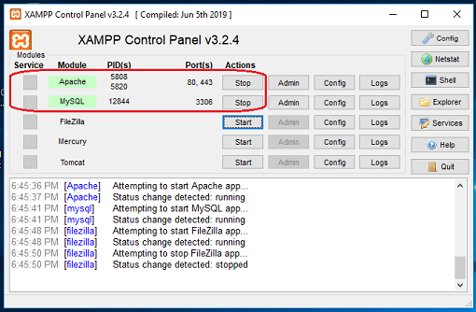Apache is a cross-platform HTTP web server. It is used to transport web material all over the world. If someone requests files, photos, or documents using their browser, HTTP servers will serve such assets to clients. MariaDB Database: XAMPP used to include MySQL DBMS; however, MariaDB has now taken its place. Apache Xampp is an open source tool used for running PHP or PERL Web applications locally using a Web server. It is available for all major operating systems and is popular with Windows users to locally build and test their Web apps.

**What isPHP:-**

PHP (Hypertext Protocol) is Open Source Programming Language used to make web pages. PHP language can run on various platforms and is compatible with almost all servers. PHP files use .php as their extension. PHP can perform functions, like from files on a system it can create, open, read, write, and close them.

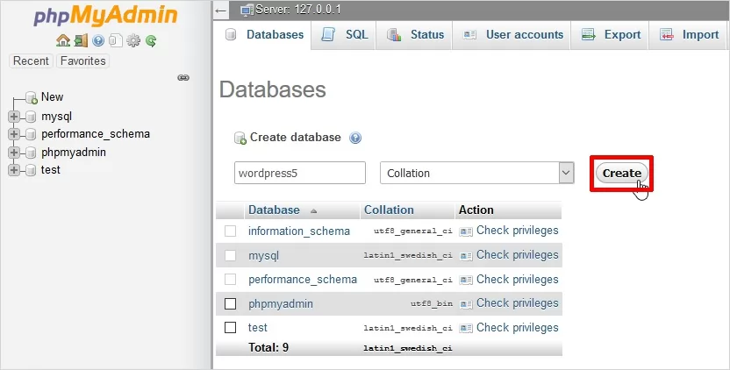**What is phpMyAdmin:-**

phpMyAdmin is a Graphical User Interface (GUI) program for Managing MySQL Databases. We can set up the Database and Table manually and run the query on them. It has a Web-based User Interface and can be installed on any server. You can access it from any computer because it is web-based.

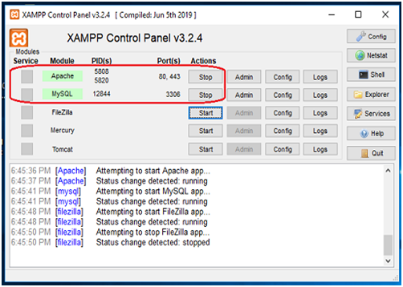**What is mysql:-**

The MySQL Database forms a vital component of the XAMPP Stack, being one of the most significant features offered by it. With XAMPP, you can use phpMyAdmin to create & use your XAMPP MySQL Database in minutes.

**2) Visual studio code (VScode):-**

Visual Studio Code is a streamlined code editor with support for development operations like debugging, task running, and version control. It aims to provide just the tools a developer needs for a quick code-build-debug cycle and leaves more complex workflows to fuller featured IDEs, such as Visual Studio IDE.

While marketing primarily to professional programmers, VS Code is an excellent editor for students and other learner just getting started with HTML and CSS.

**Features:-**

VS Code supports a wide array of programming languages from Java, C++, and Python to CSS, Go, and Dockerfile. Moreover, VS Code allows you to add on and even creating new extensions including code linters, debuggers, and cloud and web development support.

The VS Code user interface allows for a lot of interaction compared to other text editors. To simplify user experience, VS Code is divided into five main regions:

* The activity bar
* The side bar
* Editor groups
* The panel
* 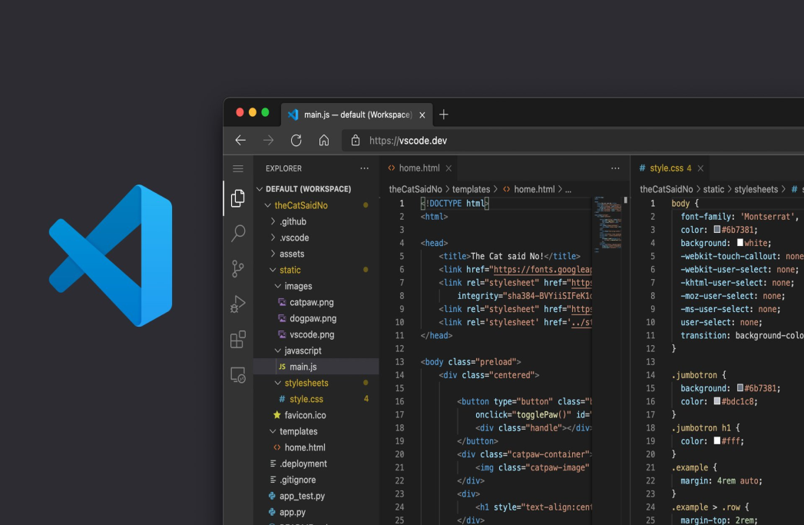The status bar

**3) MySQL Server:-**

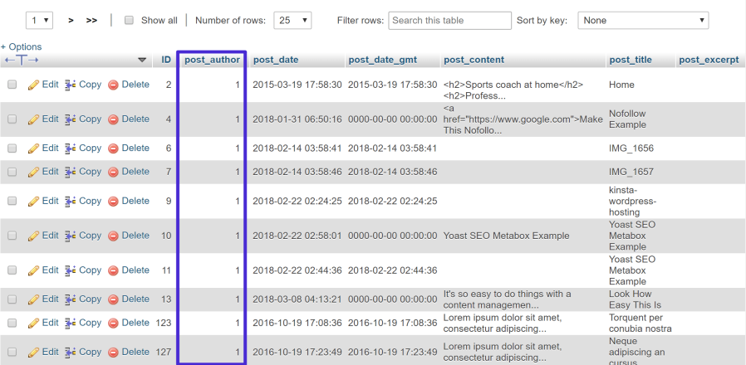

The MySQL server provides a database management system with querying and connectivity capabilities, as well as the ability to have excellent data structure and integration with many different platforms.

MySQL Database is a client/server system that consists of a multithreaded SQL server that supports different back ends, several different client programs and libraries, administrative tools, and a wide range of application-programming interfaces (APIs).

**Web Hosting:-**

When a hosting provider allocates space on a web server for a website to store its files, they are hosting a website. Web hosting makes the files that comprise a website (code, images, etc.) available for viewing online. Every website you’ve ever visited is hosted on a server.

The amount of space allocated on a server to a website depends on the type of hosting. The main types of hosting are shared, dedicated, VPS and reseller. They are differentiated by the kind of technology used for the server, the level of management provided and the additional services on offer.

**What is Domain:-**

Specific to the internet, the term domain can refer to how the internet is structured, and domain also refers to how an organization's network resources are organized. In general, a domain is an area of control or a sphere of knowledge.

A domain name is the address of a website. It's the name you type into a web browser to access that specific website. For example, the domain name for freeCodeCamp is freecodecamp.org. Domain names are important because they make it easy for people to remember the address of your website.

https://lh6.googleusercontent.com/tsUfoC0JKLbv8AuxpC_IDUeGK_RJyPMTAaNjKRmRTpQAzP3W0EZ8AIIXNZqCcTV_G0yTQzcNRKW5tlf9cN4dqu31XM7A0SBouBorwSfThJ9yluV9B05QDQLxMQSpItNRbBQvFmxF1YTvqw7yKVZx7nQ

URL:-

**What is Sub Domain:**

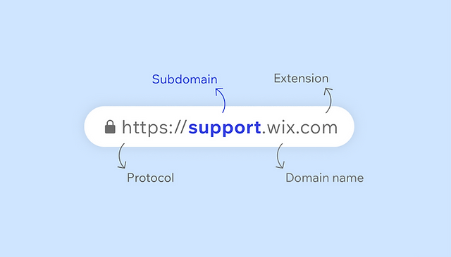

A subdomain is a prefix added to a domain name to separate a sectionof your website. Site owners primarily use subdomains to manageextensive sections that require their own content hierarchy, such asonline stores, blogs or support platforms. Subdomains function as aseparate website from its domain.

**What is HTML:-**

HTML is an acronym which stands for **Hyper Text Markup Language** which is used for creating web pages and web applications. Let's see what is meant by Hypertext Markup Language, and Web page.

**Hyper Text:** HyperText simply means "Text within Text." A text has a link within it, is a hypertext. Whenever you click on a link which brings you to a new webpage, you have clicked on a hypertext. HyperText is a way to link two or more web pages (HTML documents) with each other.

**Markup language:** A markup language is a computer language that is used to apply layout and formatting conventions to a text document. Markup language makes text more interactive and dynamic. It can turn text into images, tables, links, etc.

**Web Page:** A web page is a document which is commonly written in HTML and translated by a web browser. A web page can be identified by entering an URL. A Web page can be of the static or dynamic type. **With the help of HTML only, we can create static web pages**.

**Features of HTML:-**

1) It is a very **easy and simple language**. It can be easily understood and modified.

2) It is very easy to make an **effective presentation** with HTML because it has a lot of formatting tags.

3) It is a **markup language**, so it provides a flexible way to design web pages along with the text.

4) It facilitates programmers to add a **link** on the web pages (by html anchor tag), so it enhances the interest of browsing of the user.

5) It is **platform-independent** because it can be displayed on any platform like Windows, Linux, and Macintosh, etc.

6) It facilitates the programmer to add **Graphics, Videos, and Sound** to the web pages which makes it more attractive and interactive.

**What is CSS:-**

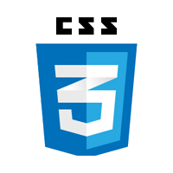CSS stands for Cascading Style Sheets. CSS describes how HTML elements are to be displayed on screen, paper, or in other media. CSS saves a lot of work. It can control the layout of multiple web pages all at once.

It's used to add style to a web page by dictating how a site is displayed on a browser. CSS is unique in that it doesn't create any new elements, like HTML or JavaScript. Instead, it's a language used to style HTML elements.

**There are three types of CSS which are given below:-**

* Inline CSS.
* Internal or Embedded CSS.
* External CSS.

**Benefits of CSS:-**

1) Faster Page Speed. More code means slower page speed.

2) Better User Experience. CSS not only makes web pages easy on the eye, it also allows for user-friendly formatting.

3) Quicker Development Time.

4) Easy Formatting Changes.

5) Compatibility across Devices.

**What is JavaScript:-**

JavaScript is a light-weight object-oriented programming language which is used by several websites for scripting the webpages. It is an interpreted, full-fledged programming language that enables dynamic interactivity on websites when applied to an HTML document. It was introduced in the year 1995 for adding programs to the webpages in the Netscape Navigator browser. Since then, it has been adopted by all other graphical web browsers. With JavaScript, users can build modern web applications to interact directly without reloading the page every time. The traditional website uses js to provide several forms of interactivity and simplicity.

Although, JavaScript has no connectivity with Java programming language. The name was suggested and provided in the times when Java was gaining popularity in the market. In addition to web browsers, a database such as CouchDB and MongoDB uses JavaScript as their scripting and query language.

**Features of JavaScript:**

1. All popular web browsers support JavaScript as they provide built-in execution environments.
2. JavaScript follows the syntax and structure of the C programming language. Thus, it is a structured programming language.
3. JavaScript is a weakly typed language, where certain types are implicitly cast (depending on the operation).
4. JavaScript is an object-oriented programming language that uses prototypes rather than using classes for inheritance.
5. It is a light-weighted and interpreted language.
6. It is a case-sensitive language.
7. JavaScript is supportable in several operating systems including, Windows, macOS, etc.
8. It provides good control to the users over the web browsers.

**What is Bootstrap:-**

Bootstrap is the popular HTML, CSS and JavaScript framework for developing a responsive and mobile friendly website. Bootstrap tutorial includes all topics of Bootstrap such as table, button, grid, form, image, alert, wells, container, carousel, panels, badges, labels, progress bar, pagination, pager, list group, dropdown, collapse, tabs, pills, navbar, inputs, modals, tooltip and popover.

**What is PHP:-**

****PHP is an open-source, interpreted, and object-oriented scripting language that can be executed at the server-side. PHP is well suited for web development. Therefore, it is used to develop web applications (an application that executes on the server and generates the dynamic page.). PHP stands for Hypertext Preprocessor.

Why use PHP:-

PHP is a server-side scripting language, which is used to design the dynamic web applications with MySQL database.

* It handles dynamic content, database as well as session tracking for the website.
* You can create sessions in PHP.
* It can access cookies variable and also set cookies.
* It helps to encrypt the data and apply validation.
* PHP supports several protocols such as HTTP, POP3, SNMP, LDAP, IMAP, and many more.
* Using PHP language, you can control the user to access some pages of your website.
* As PHP is easy to install and set up, this is the main reason why PHP is the best language to learn.
* PHP can handle the forms, such as - collect the data from users using forms, save it into the database, and return useful information to the user. **For example** - Registration form.

PHP Features:-

PHP is very popular language because of its simplicity and open source. There are some important features of PHP given below:

* **Performance:**

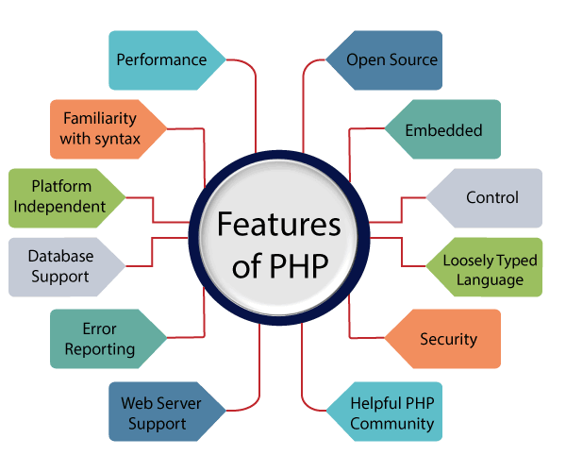PHP script is executed much faster than those scripts which are written in other languages such as JSP and ASP. PHP uses its own memory, so the server workload and loading time is automatically reduced, which results in faster processing speed and better performance.

* **Open Source:**

PHP source code and software are freely available on the web. You can develop all the versions of PHP according to your requirement without paying any cost. All its components are free to download and use.

* **Familiarity with syntax:**

PHP has easily understandable syntax. Programmers are comfortable coding with it.

* **Embedded:**

PHP code can be easily embedded within HTML tags and script.

* **Platform Independent:** PHP is available for WINDOWS, MAC, LINUX& UNIX operating system. A PHP application developed in one OS can be easily executed in other OS also.
* **Database Support:**

PHP supports all the leading databases such as MySQL, SQLite, ODBC, etc.

* **Error Reporting -**

PHP has predefined error reporting constants to generate an error notice or warning at runtime. E.g., E_ERROR, E_WARNING, E_STRICT, E_PARSE.

* **Loosely Typed Language:**

PHP allows us to use a variable without declaring its datatype. It will be taken automatically at the time of execution based on the type of data it contains on its value.

* **Web servers Support:**

PHP is compatible with almost all local servers used today like Apache, Netscape, Microsoft IIS, etc.

* **Security:**

PHP is a secure language to develop the website. It consists of multiple layers of security to prevent threads and malicious attacks.

* **Control:**

Different programming languages require long script or code, whereas PHP can do the same work in a few lines of code. It has maximum control over the websites like you can make changes easily whenever you want.

* **A Helpful PHP Community:**
* It has a large community of developers who regularly updates documentation, tutorials, online help, and FAQs. Learning PHP from the communities is one of the significant benefits.

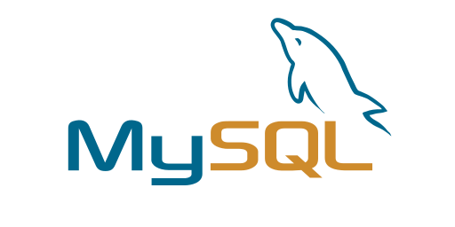**What is SQL:-**

MySQL is an open-source relational database management system. As with other relational databases, MySQL stores data in tables made up of rows and columns. Users can define, manipulate, control, and query data using Structured Query Language, more commonly known as SQL.

## MySQL works in client/server or embedded systems

MySQL Database is a client/server system that consists of a multithreaded SQL server that supports different back ends, several different client programs and libraries, administrative tools, and a wide range of application-programming interfaces (APIs). We also provide MySQL as an embedded multithreaded library that you can link into your application to get a smaller, faster, easier-to-manage standalone product.

**MySQL benefits**

MySQL is fast, reliable, scalable, and easy to use. It was originally developed to handle large databases quickly and has been used in highly demanding production environments for many years.

Although MySQL is under constant development, it offers a rich and useful set of functions. MySQL’s connectivity, speed, and security make it highly suited for accessing databases on the internet.

MySQL’s key benefits include

**Ease of use:** Developers can install MySQL in minutes, and the database is easy to manage.

**Reliability:** MySQL is one of the most mature and widely used databases. It has been tested in a wide variety of scenarios for more than 25 years, including by many of the world’s largest companies. Organizations depend on MySQL to run business-critical applications because of its reliability.

**Scalability:**MySQL scales to meet the demands of the most accessed applications. MySQL’s native replication architecture enables organizations such as Facebook to scale applications to support billions of users.

**Performance:** MySQL HeatWave is [faster and less expensive](https://www.oracle.com/mysql/heatwave/performance/) than other database services, as demonstrated by multiple standard industry benchmarks, including TPC-H, TPC-DS, and CH-benCHmark.

**High availability:** MySQL delivers a complete set of native, fully integrated replication technologies for high availability and disaster recovery. For business-critical applications, and to meet service-level agreement commitments, customers can achieve

Recovery point objective = 0 (zero data loss)

Recovery time objective = seconds (automatic failover)

**Security:** [Data security](https://www.oracle.com/security/database-security/what-is-data-security/) entails protection and compliance with industry and government regulations, including the European Union General Data Protection Regulation, the Payment Card Industry Data Security Standard, the Health Insurance Portability and Accountability Act, and the Defense Information Systems Agency’s Security Technical Implementation Guides. MySQL Enterprise Edition provides advanced security features, including authentication/authorization, transparent data encryption, auditing, data masking, and a database firewall.

**Flexibility:**The MySQL Document Store gives users maximum flexibility in developing traditional SQL and NoSQL schema-free database applications. Developers can mix and match relational data and JSON documents in the same database and application.

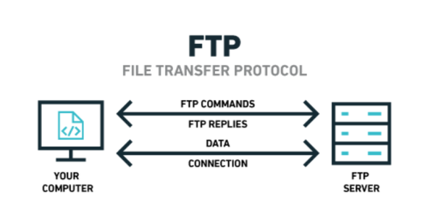**What is FTP:-**

FTP (File Transfer Protocol) is a network protocol for transmitting files between computers over Transmission Control Protocol/Internet Protocol (TCP/IP) connections. Within the TCP/IP suite, FTP is considered an application layer protocol.

In an FTP transaction, the end user's computer is typically called the local host. The second computer involved in FTP is a remote host, which is usually a server. Both computers need to be connected via a network and configured properly to transfer files via FTP. Servers must be set up to run FTP services, and the client must have FTP software installed to access these services.

Although many file transfers can be conducted using Hypertext Transfer Protocol (HTTP) -- another protocol in the TCP/IP suite -- FTP is still commonly used to transfer files behind the scenes for other applications, such as banking services. It is also sometimes used to download new applications via web browsers.

### How does FTP work:-

Here is how a typical FTP transfers works:

1. A user typically needs to log on to the FTP server, although some servers make some or all of their content available without a login, a model known as anonymous FTP.
2. The client initiates a conversation with the server when the user requests to download a file.
3. Using FTP, a client can upload, download, delete, rename, move and copy files on a server.

FTP sessions work in active or passive modes:

* **Active mode.** After a client initiates a session via a command channel request, the server creates a data connection back to the client and begins transferring data.
* **Passive mode.** The server uses the command channel to send the client the information it needs to open a data channel. Because passive mode has the client initiating all connections, it works well across firewalls and network address translation gateways.

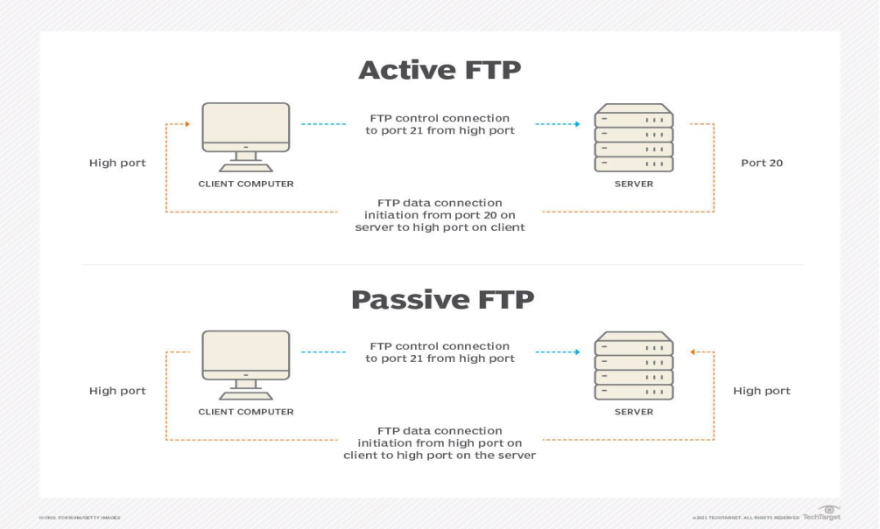

### Why is FTP important and what is it used for?

FTP is a standard network protocol that can enable expansive file transfer capabilities across IP networks. Without FTP, file and data transfer can be managed with other mechanisms -- such as email or an HTTP web service -- but those other options lack the clarity of focus, precision and control that FTP enables.

FTP is used for file transfers between one system and another, and it has several common use cases, including the following:

* **Backup.** FTP can be used by backup services or individual users to backup data from one location to a secured backup server running FTP services.
* **Replication.** Similar to backup, replication involves duplication of data from one system to another but takes a more comprehensive approach to provide higher availability and resilience. FTP can also be used to facilitate this.
* **Access and data loading.** FTP is also commonly used to access shared web hosting and cloud services as a mechanism to load data onto a remote system.

**SDLC(Software Development Life Cycle):**–

SDLC stands for "Software Development Life Cycle." It is a process that is followed for developing software systems. The SDLC process defines the steps that are involved in developing a software system, from the initial planning stages to the final deployment of the software. There are several different models that can be used to guide the SDLC process, each with its own set of steps and activities .

Some common SDLC models include the Waterfall model, the Agile model, the Spiral model, and the V-shaped model.

**Pic:-**

The Waterfall model is a linear model that follows a strict set of steps, with each step building upon the previous one. The Agile model is a flexible, iterative approach that allows for frequent changes and adaptations during the development process. The Spiral model is a risk- driven approach that involves iterative development and risk assessment. The V-shaped model is a combination of the Waterfall model and the Iterative model, with each step in the process followed in a linear fashion, but with the possibility of returning to earlier steps if necessary.

###### [Waterfall Model](https://www.javatpoint.com/software-engineering-waterfall-model)

The waterfall is a universally accepted SDLC model. In this method, the whole process of software development is divided into various phases.

Linear ordering of activities has some significant consequences. First, to identify the end of a phase and the beginning of the next, some certification techniques have to be employed at the end of each step. Some verification and validation usually do this mean that will ensure that the output of the stage is consistent with its input (which is the output of the previous step), and that the output of the stage is consistent with the overall requirements of the system.

##### [Incremental Model in SDLC](https://www.guru99.com/what-is-incremental-model-in-sdlc-advantages-disadvantages.html)

The incremental model is not a separate model. It is essentially a series of waterfall cycles. The requirements are divided into groups at the start of the project. For each group, the SDLC model is followed to develop software. The SDLC life cycle process is repeated, with each release adding more functionality until all requirements are met. In this method, every cycle act as the maintenance phase for the previous software release. Modification to the incremental model allows development cycles to overlap. After that subsequent cycle may begin before the previous cycle is complete.

##### 

##### V-[Model in SDLC](https://www.guru99.com/v-model-software-testing.html)

In this type of SDLC model testing and the development, the phase is planned in parallel. So, there are verification phases of SDLC on the side and the validation phase on the other side. V-Model joins by Coding phase.

##### [Agile Model in SDLC](https://www.guru99.com/agile-scrum-extreme-testing.html)

Agile methodology is a practice which promotes continue interaction of development and testing during the SDLC process of any project. In the Agile method, the entire project is divided into small incremental builds. All of these builds are provided in iterations, and each iteration lasts from one to three weeks.

##### Big bang model

Big bang model is focusing on all types of resources in software development and coding, with no or very little planning. The requirements are understood and implemented when they come.

This model works best for small projects with smaller size development team which are working together. It is also useful for academic software development projects. It is an ideal model where requirements is either unknown or final release date is not given.

###### [RAD Model](https://www.javatpoint.com/software-engineering-rapid-application-development-model)

RAD or Rapid Application Development process is an adoption of the waterfall model; it targets developing software in a short period. The RAD model is based on the concept that a better system can be developed in lesser time by using focus groups to gather system requirements.

* Business Modeling
* Data Modeling
* Process Modeling
* Application Generation

**Spiral model:-**

**Pic:-**

**Why we are using Spiral SDLC model in our project :-**

The Spiral SDLC model is a risk-driven software development process model that is based on the idea of prototyping. In this model, the development process begins with a small set of requirements that are refined as the project progresses through multiple cycles, or "spirals." Each cycle consists of four phases: planning, risk analysis, engineering, and evaluation.

One of the main benefits of the Spiral model is that it allows for a high level of flexibility and iteration, which can be particularly useful in projects where requirements are not well-defined or are likely to change significantly over the course of the project. It can also be useful in projects where there are a lot of unknowns or high levels of risk, as it

allows for a systematic approach to identifying and addressing these risks.

Overall, the Spiral model can be a good choice for projects where a high level of collaboration and risk management is required, and where the development team needs to be able to adapt and respond to changing requirements as the project progresses.

##### **Software Project Planning :-**

Project planning is an organized and integrated management process that focuses on the actions necessary for the project's practical completion. It avoids problems in the project, such as changes in the project's or organization's objectives, resource shortages, and so forth. Project planning also aids in improved resource use, and the most efficient use of a project's allowed time. The following are the other project planning goals. Estimating the subsequent attributes of the project:

* **Project size:**

What’s going to be downside quality in terms of the trouble and time needed to develop the product?

* **Cost:**

What proportion is it reaching to value to develop the project?

* **Duration:**

However long is it reaching to want complete development?

* **Effort:**

What proportion effort would be required?

The effectiveness of the following designing activities relies on the accuracy of those estimations.

* planning force and alternative resources
* workers organization and staffing plans
* Risk identification, analysis, and abatement designing
* Miscellaneous arranges like quality assurance plan, configuration, management arrange, etc.

**Pic:-**

##### **System Design:-**

System design is the process of designing the elements of a system such as the architecture, modules and components, the different interfaces of those components and the data that goes through that system.System Analysis is the process that decomposes a system into its component pieces for the purpose of defining how well those components interact to accomplish the set requirements.

**There are several strategies that can be used to design software systems, including the following:**

1. Top-Down Design: This strategy starts with a high-level view of the system and gradually breaks it down into smaller, more manageable components.
2. Bottom-Up Design: This strategy starts with individual components and builds the system up, piece by piece.
3. Iterative Design: This strategy involves designing and implementing the system in stages, with each stage building on the results of the previous stage.
4. Incremental Design: This strategy involves designing and implementing a small part of the system at a time, adding more functionality with each iteration.
5. Agile Design: This strategy involves a flexible, iterative approach to design, where requirements and design evolve through collaboration between self-organizing and cross-functional teams.

**Gantt chart:-**

**Pert chart:-**

**Flow chart:-**

**ERD:-**

**DFD:-**

**Code:-**

##### **Software Testing Techniques:-**

The categorization of software testing is a part of diverse testing activities, such as test strategy, test deliverables, a defined test objective, etc. And software testing is the execution of the software to find defects. A strategy for software testing must accommodate low-level test that are necessary to verify that a small source code segment can be correctly implemented as well as high –level tests that validate major system functions against customer requirements.

Types of Testing

1. Alpha Testing: -

Testing after code is mostly complete or contains most of the functional and prior to end user being involved. More often this testing will be performed in house or by an outside testing firm in close cooperation with the software engineering department.

2. Beta Testing: -

Testing after the product is code complete. Betas are often widely distributed or even distributed to the public at large in hopes that they will buy the final product when it is released.

3. Functional Testing: -

Testing two or more modules together with the intent of finding defects, demonstrating that defects are not present, verifying that the modules performs its intended functions as stated in the specification and establishing confidence that a program does what it is supposed do.

4. Configuration Testing: -

Testing to determine how well the product works with a broad of the hardware/peripheral equipment configurations as on the different operating systems and software.

5. Pilot Testing: -

Testing that involves the users just before actual release to ensure that users become familiar with the release contents and ultimately accept it. Typically involves many users, is conducted over a short period of time and is tightly controlled.

6. System Integration Testing: -

Testing a specific hardware/software installation. This is typically performed on a COTS system or any other system comprised or the disparate parts where custom configurations and /or unique installation are the norm .

7. Software Testing: -

The process of exercising software is with the intent of ensuring that the software system meets its requirements and the user   expectations and doesn’t file in an unacceptable manner .

8. Security testing: -

Testing of database and network software in order to keep company data and resources from mistaken/ accidental users, hackers and other malevolent attackers.

9. Installation Testing: -

Testing with the intent of determining if the product will install on a variety of platforms and how easily it installs .

10. Compatibility Testing: -

Testing used to determine whether other system software components such as browsers, utilities and competing software would conflict with the software being tested.

# Maintenance:-

The maintenance of existing software can account for over 60 percent of all effort expended by development organization and the percentage continues to rise as more software is produced. There are four different kinds of maintenance:

1. **Corrective maintenance**: Corrective maintenance changes the software to correct defects.
2. **Adaptive maintenance**: Adaptive maintenance results in modifications to the software to accommodate changes to its external environment.
3. **Perfective maintenance**: Perfective maintenance extends the software beyond its original functional requirements.
4. **Preventive maintenance**: Preventive maintenance often called software reengineering must be conducted to enable software to serve the needs of its end users. In essence preventive maintenance makes changes to computer programs so that they can be more easily corrected, adopted and enhanced.

The following software is designed into modules (having well defined inputs, outputs and non-overlapping specific usage) – which makes it easier to maintain. Suppose a correction or perfection to the code is made due to user requirement; the effect remains within the particular module; the rest of the software remain intact.

**Future scope system:-**

**Conclusion:-**

**Bibliography:-**

For successfully completing my Project , I have taken help from some websites and books. During the development of the assignment I have use the following books and websites links.

References:

1. <https://www.apachefriends.org/>
2. <https://www.mysql.com/>
3. PHP Crash Course Book
4. tutorialspoint.com
5. <https://www.php.net/>
6. <https://www.php.net/>